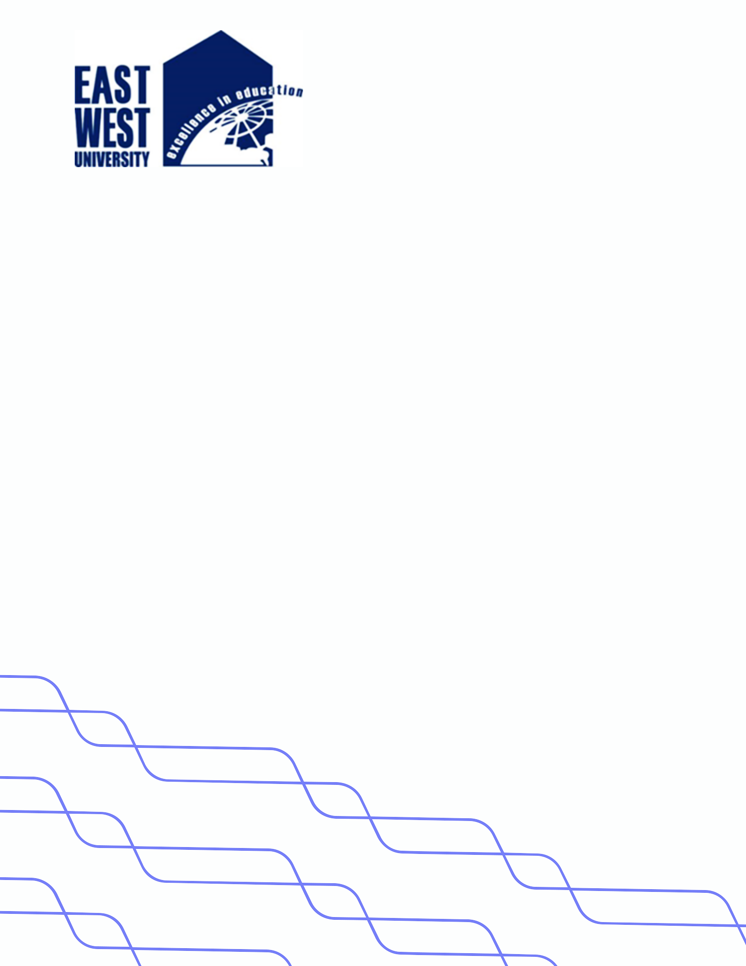

**LAB-08**

**Title: Algorithm to implement insert, delete and display operations on queue.**

**Name: Azizul Abedin Azmi**

**ID: 2022-1-60-130**

**Section: 03**

**Course Code: CSE207**

**Course Title: (Data Structures)**

**Date: 29/04/2024**

**Course Instructor:**

**Dr. Anup Kumar Paul**

**Associate Professor**

**Department of Computer Science and Engineering**

**Source Code:**

**Queue.java:**

package Lab08;

import java.util.Scanner;

public class Queue {

    private Node front;

    private Node rear;

    public Queue() {

        front = null;

        rear = null;

    }

    public boolean isEmpty() {

        return front == null;

    }

    public void insert(int data) {

        Node newNode = new Node(data);

        if (isEmpty()) {

            front = newNode;

            rear = newNode;

        } else {

            rear.next = newNode;

            rear = newNode;

        }

        System.out.println("Data inserted in the queue: " + data);

    }

    public void delete() {

        if (isEmpty()) {

            System.out.println("Queue is Empty");

            return;

        }

        int deletedData = front.data;

        if (front == rear) {

            front = null;

            rear = null;

        } else {

            front = front.next;

        }

        System.out.println("Deleted element from the queue: " + deletedData);

    }

    public void display() {

        if (isEmpty()) {

            System.out.println("Queue is Empty");

            return;

        }

        System.out.println("Elements in the Queue are:");

        Node current = front;

        while (current != null) {

            System.out.print(current.data + "\t");

            current = current.next;

        }

        System.out.println();

    }

}

**Main.java:**

package Lab08;

import java.util.Scanner;

public class Main {

    public static void main(String[] args) {

        Scanner scanner = new Scanner(System.in);

        Queue queue = new Queue();

        // Insertion

        System.out.println("Enter number of elements to insert:");

        int numElements = scanner.nextInt();

        System.out.println("Enter elements to insert:");

        for (int i = 0; i < numElements; i++) {

            int data = scanner.nextInt();

            queue.insert(data);

        }

        // Display

        queue.display();

        // Deletion

        System.out.println("Do you want to delete an element? (Y/N)");

        char choice = scanner.next().charAt(0);

        if (choice == 'Y' || choice == 'y') {

            queue.delete();

            queue.display();

        }

        scanner.close();

    }

}

**Node.java:**

package Lab08;

public class Node {

    int data;

    Node next;

    public Node(int data) {

        this.data = data;

        this.next = null;

    }

}

**Output:**

